STC Team Meeting (1/24)

# Timestamp:

-Friday, Jan 24 from 3:00 - 4:00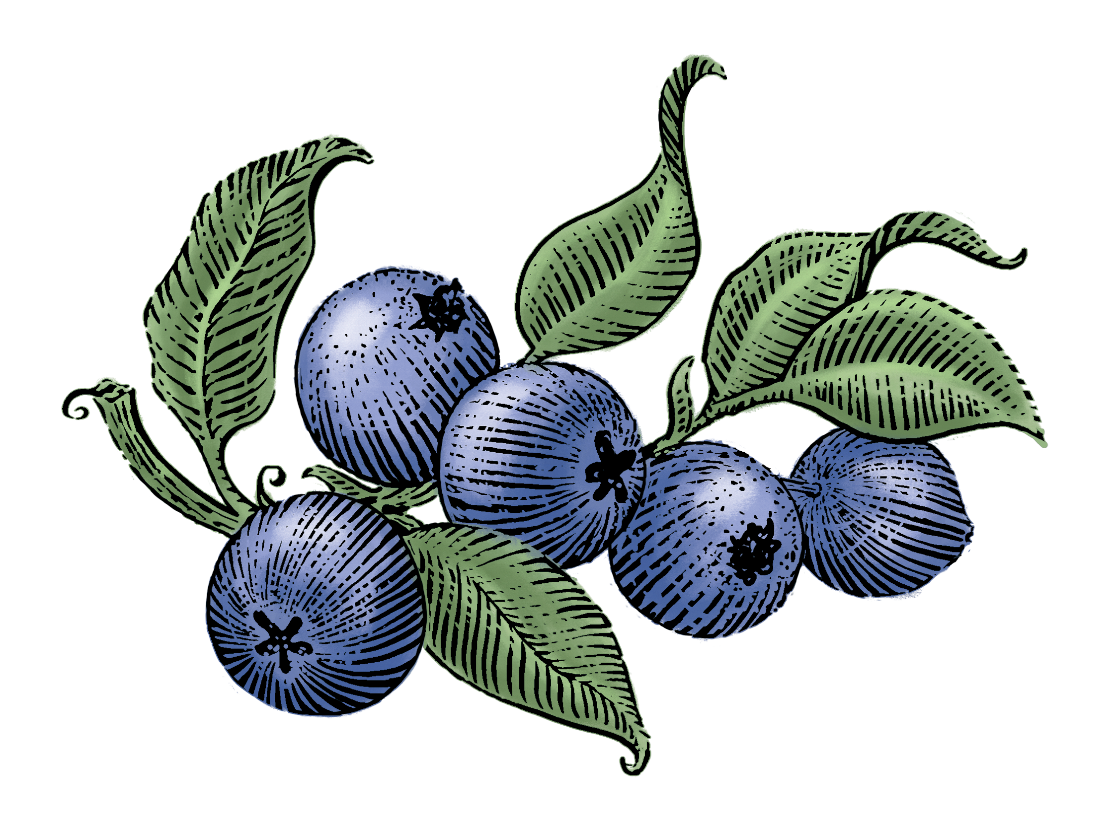

# Location:

-Walker 120

# Members Present:

-Jayleen, Piper, Bekah

# Tasks:

-Complete sections 1 + 2 of Part C

-Assign editing/designing given handouts

-Branding/color palette/logo

# Discussion Topics and Conclusion:

-Design Ideas: [siggi’s](https://siggis.com/)

-Editing:

-Redesign:

-Color Palette:

#### Consideration: Client is afraid of the berry color theme being “too dark”.

-Logo: Waiting for files from Erika

-Contact information:

+Piper: [pmschlae@mtu.edu](mailto:pmschlae@mtu.edu), 906-281-9590

# Proposed Topics for Next Meeting:

-Pick individual editing/re-design projects

**-Color palette**

-Logo